Activity 7: Test Plan
Samantha Krall
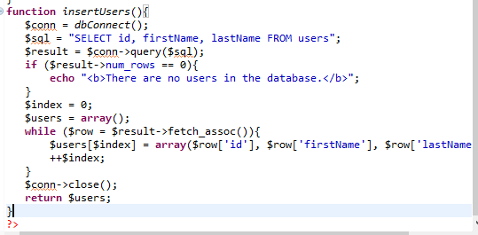

Test Plan: | Pass | Fail
Register user without filling out form; ensure proper data validation errors displayed | X
Register new user; ensure positive success message is displayed | X
Register existing user; ensure proper error message displayed | X
Login without filling out form; validation error displayed | X
Login with incorrect username; validation error displayed |  | X
Login with incorrect password; validation error displayed |  | X
Login with correct password and username; main page displays | X
Logoff the application; ensure start application page displays | X
Create new blog without filling out the form; validation errors displayed |  | X
Create new blog without filling out blog title, content; validation errors displayed | X
Create new blog | X
Blog list – display title and option to view blog | X
Update and delete blog options are displayed for blog owners only (display my blogs) |  | X
View blog with navigation back to blog list available | X
Update your blogs | X
Blog delete page | X
Search form – title and/or content | X
Comment on a blog | X

The MySQL functions are procedural and use manual escaping. MySQLi is a replacement for the MySQL functions, with object oriented and procedural versions. It has support for the prepared statements. PHP Data Objects (PDO) is a general database abstraction layer with support for MySQL among many other databases. It provides prepared statements, and significant flexibility in how data is returned. MySQL is a historical API. MySQLi is a new version of the historical API, it should perform better and have a better set of function, also the API is object oriented. PDO_MySQL is the MySQL for the PDO. PDO has been introduced in PHP, the project aims to make a common API for all the databases access, so in theory you should be able to migrate between RDMS without changing any code (if you do not use specific RDBM function in your queries), also object oriented.
 | PDO | MySQLi
Database support | 12 different drivers | MySQL only
API | OOP | OOP + procedural
Connection | Easy | Easy
Named Parameters | Yes | No
Object mapping | Yes | Yes
Prepared statements (client side) | Yes | No
Performance | Fast | Fast
Stored procedures | Yes | Yes
The main difference that I have found is with the database drivers support. MySQLi has support from MySQL only while PDO has the support for twelve different database drivers. Both are safe as long as the developer uses them the way they are supposed to be used (read: prepared statements). Both PDO and MySQLi are extremely similar but there are slight differences in syntax. MySQLi follows the old school PHP snake_case convention while PDO uses camelCase. Additionally, MySQLi’s methods are used as object properties, while PDO uses the traditional syntax for functions.

References:
http://didefth.gr/soft4u/?p=2915
https://code.tutsplus.com/tutorials/pdo-vs-mysqli-which-should-you-use--net-24059
https://websitebeaver.com/php-pdo-vs-mysqli

